**TEAM ID:** [**IBM-Project-38676-1660384301**](https://github.com/IBM-EPBL/IBM-Project-38676-1660384301)

**PROJECT NAME:IOT Based Smart Crop Protection System For Agriculture**

**STEP 1:Go to the ibm cloud**

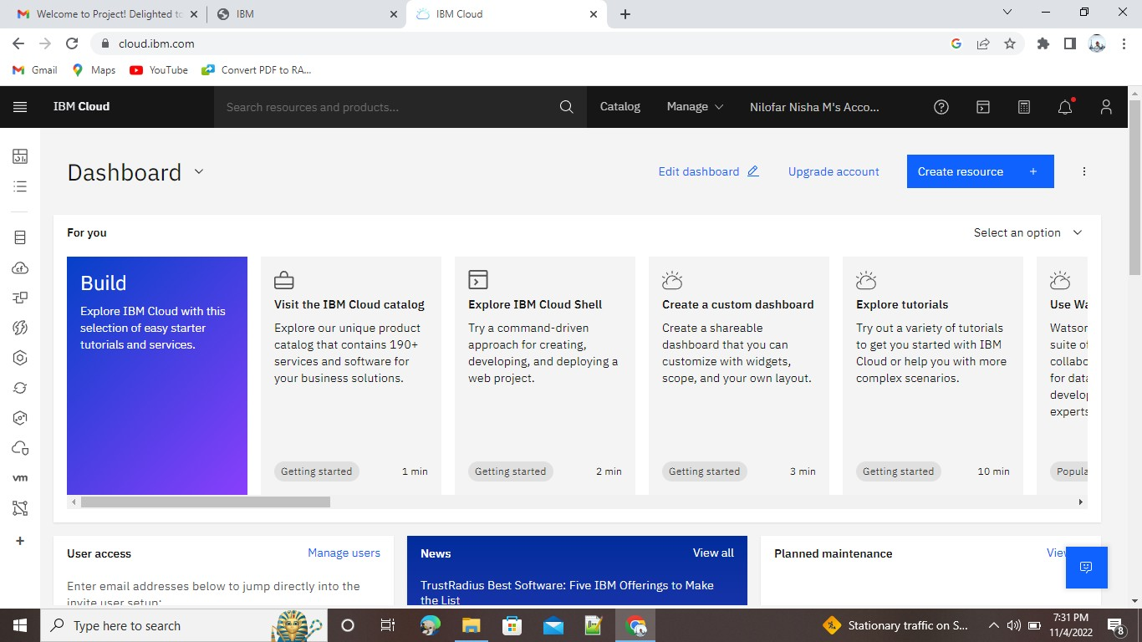

**STEP 2:** Click the catlog and click resource list and open the services

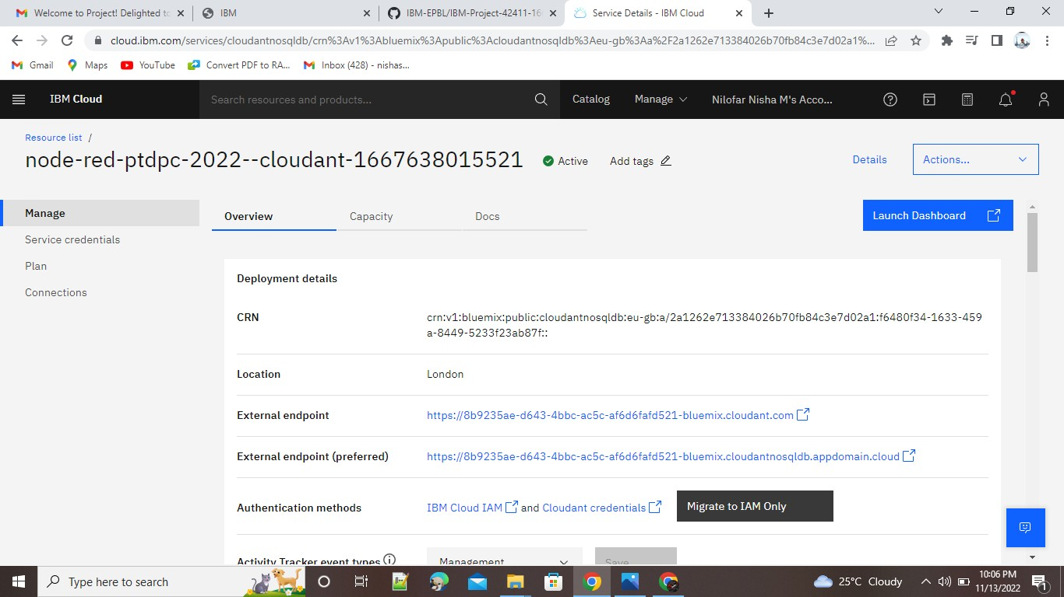

**STEP 4:** Go to launch dashboard and create document

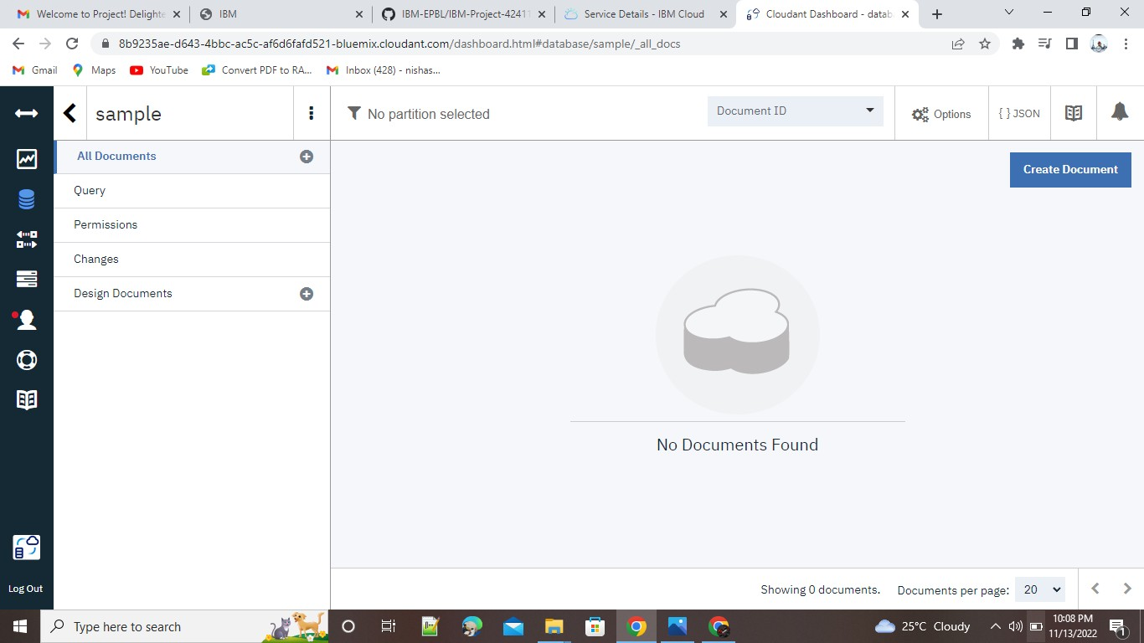

**STEP 5:** create document

